Venus and Freud

by Amanda Padoan

MPhil Student, University of Cambridge ________________________________________________________________________

Freud once informed a patient, 'The psychoanalyst, like the archaeologist, must uncover layer after layer of the patient’s psyche, before coming to the deepest, most valuable treasures' (Panjekeff, 1972, p. 139). Excavation is an apt metaphor for Freud's method, but did he hit bedrock? The phallocentrism of his theories, in particular, is widely discredited as a problem of the man and his moment. But Freud's phallocentrism may also be understood in terms of his engagement with archeology, specifically his own collection of Bronze Age and Classical figurines. If he had applied psychoanalytic theory to more ancient representations of the human form, his theories might have turned out quite differently.

Certainly, Freudian phallocentrism does not explain the dominance of female iconography during the Upper Paleolithic. Midway through this long and creative period, Europe witnessed an explosion of visual art and material culture centered around the female body, while male representations are scarce. Dolní Věstonice, a settlement in a Czech River Valley, illustrates the scale of production. About 26,000 years ago, the kilns of Dolní Věstonice were firing Venus[1] statuettes by the thousands. We know because some tiny women didn't survive. When the heat exceeded 800 °C, they exploded from thermal shock.[2] Archeologists found shattered hips, cracked breasts, split bellies--some 3200 terracotta fragments in all--scattered across the site (Vandiver, Soffer, Kilma and Svoboda, 1998).

Intact, she is a wonder to behold (Figure 1: Dolní Věstonice Venus, n.d.):

Figure 1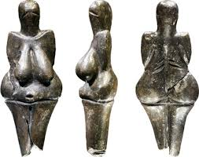

Credit: Petr Novák, Wikimedia

Passing over the nub of her head, the eye moves down her pendulous breasts, across her wide rump and gravid belly. Despite evident signs of fecundity, her symbolism provokes considerable debate (Dixson and Dixson, 2011; Harrod, 2011). Although her identity eludes gender archeologists, she clearly possessed one and retained it over an extended period. 'A person's identity is not found in behavior, nor --important though this is-- in the reactions of others, but in the capacity *to keep a particular narrative going*' (Giddens, 1991, p. 54; original emphasis). From Siberia to Iberia, from the shores of Lake Baikal to the Atlantic Coast, she kept her narrative going by remaining stylistically consistent for 40,000 years.[3] Indeed, she represents the most enduring gendered subject in the history of humanity. Who was she? Her presence is felt on the walls and in the clefts of caves. She communicates in curves of clay, antler, ivory, and bone. Her staying power is greater than any subsequent rival. Classical Venus survived a mere 1100 years, Greek and Roman eras combined. No stranger to beauty contests, she might have put it this way: What does Paleolithic Venus have that I don't?

She has no history for one thing. Prehistoric art offers a clean slate, the opportunity to observe minds and bodies performing gender or experiencing sexuality, unburdened by their own conceptualizations. But the slate is clean on only one face. Our side is heavily inscribed. '[G]ender is an identity tenuously constituted in time, instituted in an exterior space through a stylized repetition of acts', such as the sustained creation and worship of a gendered subject (Butler, 1990, pp. 139-40). Although original meaning is lost, if we accept the premise that gender and sexuality are socially constructed, Paleolithic Venus seems to be a cipher. The puzzle is, who is being deciphered? Without our knowledge of her creators' intent, Venus induces a placebo response, forcing us to examine how we ourselves examine questions of gender and sexuality. Such analysis brings modern epistemes into an ancient silence. It is a gross imposition. What use, then, are social constructs if we know next to nothing about the society under construction? If the aim is to analyze the gendered subject of prehistory, rather than ourselves, we must find an alternative to the social constructivist monolith and invoke psychoanalytic theory. If we share similar minds, the same neurology, as the artists who created this art, could we deploy our own subconscious to understand theirs?

Psychoanalysis presumes the understanding of identity's essential grounding in sexuality. As we endeavor to 'keep [our] narrative going', identity-formation responds to symbolic structures that, Freud argues, are embedded in every human mind regardless of temporal or cultural context. With social constructionism, a situated perspective is everything. In psychoanalysis, it's nothing. Our psyches are hardwired into the universal. As such, psychoanalytical theory offers the hope, maybe the only means, of recovering sublimated narratives of Paleolithic Venus.

Freud notes that 'male deities appear first as sons beside the great mothers', but then he stops short. His analysis remains within the confines of the 'patriarchal order' (Freud, 2001, p. 83) that announces '[women] show less sense of justice than men [and] they are less ready to submit to the great exigencies of life' (Freud, 1977b, p. 342). Conveniently, Freud dismisses what he cannot resolve as 'the riddle of femininity' and disowns women as 'the problem' when the fundamental problem is his own phallocentric view of the subconscious (Freud, 1968c, pp. 116, 113). It blinds him to profound shifts in symbolism that occurred on the cusp of the Neolithic. Around 10,000 years ago, climate change radically altered the societies that produced Paleolithic Venus. Permafrost conditions thawed; mega fauna went extinct; ancient ways of life all but vanished. Semi-settled hunter-gatherer communities of the Upper Paleolithic required a high degree of cooperation for survival. Their art suggests that some women filled a valued, if not sacred position, because representations of the vulva and Venus are privileged, second only to those of animals upon which the community fed and clothed itself and of predators it feared.[4] At times, Venus transforms into a therianthrope, the Venus of Tolentino, an enigmatic cow-headed woman scratched on chert.[5] In other representations, the vulva subsumes animistic forms when, as in Roc-aux-Sorciers, it masks older images of bison like a prehistoric palimpsest.[6] Her presence fills gendered spaces, such as the womb room at Gargas Cave, where a slit in the rock leads into a cavity thickly plastered in ochre.

Then she recedes. Displaced by the settled, agricultural lifestyles of the Neolithic, Paleolithic Venus fractures into a myriad of derivative archetypes. Many of them clutter Freud's desk and curio cabinets. He referred to them affectionately as 'my old and dirty gods' (1889, p. 363) and admitted, 'I have sacrificed a great deal for my collection of Greek, Roman and Egyptian antiquities [and] have actually read more archaeology than psychology' (1975, p. 403). As he teased out universal archetypes, Freud failed to recognize how his source material was drawn from broadly the same phase in social development. Egyptian, Roman, and Greek societies, structured by hegemonic systems of ownership, patriarchy, and kingship, do not resemble the world of Paleolithic Venus. Her power draws from another time. Like Freud's desk, there is considerable clutter in his psychoanalytic approach to gender, such that he could not see the forest for the tree trunks. Freud hordes metonymies and assigns gender to junk:

All elongated objects, such as sticks, tree trunks and umbrellas (the opening of these last being comparable to an erection) may stand for the male organ – as well as all long sharp weapons such as knives, daggers and pikes… Boxes, cases, chests, cupboards and ovens represent the uterus, and also hollow objects, ships and vessels of all kinds (1991, pp. 470-71).

The sheer ubiquity of gender becomes his distraction. Despite an intense engagement with archeology, Freud is sifting through topsoil, missing the treasures below.

In Paleolithic societies--not egalitarian, *per se*, but certainly cooperative--Venus wasn't chattel yet. On his desk, the classical feminine exists differently, a 'hollow object' to be filled with masculine ideation like the Balsamarium in his collection.[7] This copper vessel, soldered in the shape of a maenad’s empty braincase, once contained resin. In Ancient Greek, maenad means 'raving madwoman'. Small wonder Freud bought her. She stares blankly ahead, affirming why 'in Freud’s version of the origins of religion and the development of civilization, women’s power was erased: males dominated and their battles for supremacy brought society into being' (Burke, 2007, p. 7). The maenad's desktop companions--Isis[8], Artemis[9], and Ishtar[10]--are familiar archetypes. Isis is the lactating mother; Artemis, the virgin; Ishtar, the seductress. Ishtar's cult practiced sacred prostitution, and her clay effigy signifies female genitalia with a crude peg hole, positioned where the penis might extend from the male abdomen as though her divine body were in need of a plug. Janice Burke, curator of Freud's archeology collection, questions why '[h]is treasured goddesses were unable to influence his opinion', but they certainly did (2007, p. 7). Freud's theories describe the pantheon on his desk. Despite their powerful attributes, these female deities are categorically compliant. What power they possess is regulated by tropes of chastity, motherhood, and male-pleasing eros. Unlike Paleolithic Venus, they are products of a lopsided world.

Freud does not look past the figurines on his desk to discover the woman who reigned before them all. Instead, he deprecates the creative drive that produced Paleolithic Venus as spent power: 'Art, which certainly did not begin as art for art’s sake, originally served tendencies which today have for the greater part ceased to exist. Among these we may suspect various magic intentions' (Freud, 1919, p. 150). He fails to consider why some symbolic regimes should fade into oblivion, while his, universal by definition, never could. It is said, no problem can be solved from the same level of consciousness that created it.[11] Such is the obstacle Freud faced, writing some 10,000 years into the reign of the phallus. Excavating the wrong strata, buried beneath his own archeological metaphor, he cannot escape a phallocentric view of human history despite curvaceous evidence to the contrary.

By Freud's time, Paleolithic Venus statuettes were known to be the most ancient of human representations. It was also common knowledge that coeval masculinities were, for the most part, missing. Her presence and his absence embody a counterpoint to which Freud never adequately responds, although Venus' radical substitution is pure Freudian displacement. At the dawn of the Neolithic, man and his member fully debut in art history. They've never gone away. What prompted their emergence? Had Freud contemplated the implications of this iconographic shift from vulva to phallus, he might have unlocked a realm of contrasts, bridging Paleolithic and Neolithic minds. For him, the subconscious had to be stabilized, contained within its skull, given freedom to roam but never adapt. In reality, as the world of the late Pleistocene was melting and transforming, the subconscious kept apace. Paleolithic Venus didn't disappear. She slimmed down, put on a skirt, and began to reflect the anxieties of her new environment, which increasingly promoted male ownership over human and natural resources.

Freud's focus on the phallus ignores the dominant female iconography of the Upper Paleolithic and responds to social conditions launched by the Neolithic transition. At this point, Paleolithic Venus is sufficiently subdued for Freudian theory to take root. In Freud's psychoanalytic scaffolding, the penis is the pillar of identity-formation and a buttress to the ego. During the phallic phase, children notice a penis sprouting from boys' bodies. Girls covet the organ[12], and boys fear losing it. Anxiety ripens to dread. Surely the world is teeming with thieves. Mother, the girl's rival for Father, and Father, the boy's rival for Mother, are prime suspects. For the girl, Mother is already to blame for 'send[ing] her into the world so insufficiently equipped...' (Freud, 1977b, p. 338). As for the boy, Father is merely waiting for the opportune moment to slice (Freud, 1991; 1968a; 1968b; 1977b).

If this over-wrought family seems familiar, they should be. Their progeny vie for space on Freud's desk. In Greek mythology, the castration of Uranus by his son, Kronos, and the consequent birth of Aphrodite, our latter-day Venus, is a paradox of consummation:

And Heaven came, bringing on night and longing for love, and he lay about Earth spreading himself full upon her. Then the son from his ambush stretched forth his left hand and in his right took the great long sickle with jagged teeth, and swiftly lopped off his own father's genitals and cast them away... into the surging sea, they were swept away over the main a long time: and a white foam spread around them from the immortal flesh, and in it grew a maiden. (Hesiod, 2006, pp. 17-19)

Beginning with the sexual initiation of nightfall, the slashing of universal potency resolves in the generation of the erotic subject from Uranus' discarded seminal fluid. Venus, the apotheosis of eros, is conceived from the antithesis of sex. If Paleolithic Venus represents fecundity, her wanton, wasp-waisted derivative represents sexuality dissociated from reproduction. Paleolithic Venus is deeply sublimated by now, her generative powers in check as the old world order is severed to make way for the new. Venus, rising from 'a white foam', embodies the sexual experience of men for whom coitus never leads to the bonds and bondage of motherhood. Such are the sons, brothers, fathers, and grandfathers of the figurines on Freud's desk--Artemis, Athena, Eros, Isis--who bear witness to the castration complex. In a preemptive strike, sons are castrating their fathers. Kronos loses his testes to his own son Zeus who seizes the universe as his father before him. Egyptian mythology mirrors the Greek. Horus, son of Isis, castrates his stepfather, Set, in order to avert chaos. He too gains the universe. As Freud explains, envy is at the heart of the castration complex and expresses itself in violent drives to possess what another owns (1968a, 1968b).

When did compulsive ownership become such a defining feature of selfhood or, more specifically, manhood? We know territorial violence remains a constant variable in human history.[13] The communities of Paleolithic Venus undoubtedly endured conflict, violence that may have included rape. We know some women were impregnated by outsiders due to the significant percentage of Neanderthal DNA in modern European populations, potentially the genetic traces of the seizure of women's bodies. Artistically, however, Paleolithic artists seldom depict violence. One rare example is a 17,000-year-old painting at Lascaux called 'The Shaft of the Dead Man'[14] [Figure 2, n.d.].

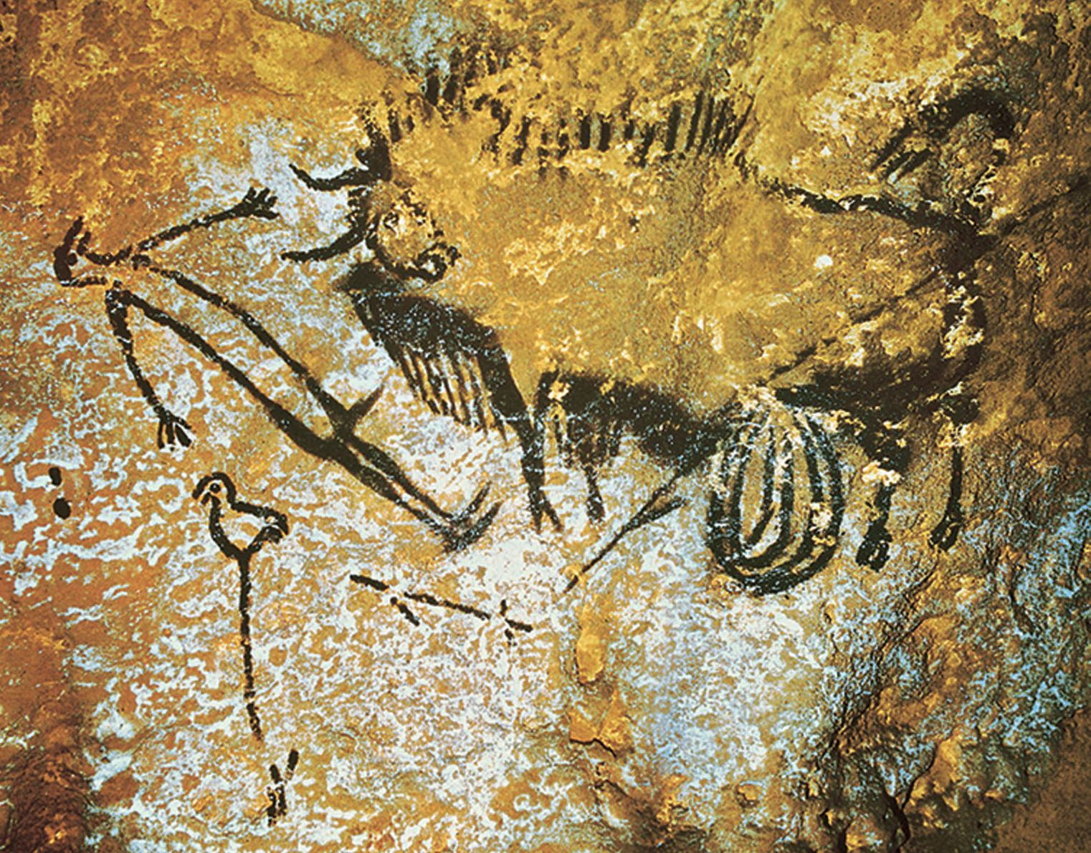

Fig. 2 Credit: Centre National de Préhistoire, Wikimedia

A gored bison, intestines dragging, stands over a bird-headed man and his broken spear. In this depiction, a powerful animal is the adversary. The man's penis, a charcoal dash, seems incidental. Neolithic art, in contrast, regularly features sex and man-on-man violence. Tellingly, no prehistoric imagery of coitus had been discovered in Freud's time. Only one is now known. A surface etching on a flat rock, the image appears to be more of a doodle[15] than a meditation (Bahn, 1986). Yet during the Neolithic, sex and its incumbent anxieties are painted, sculpted, chiseled, and inscribed graphically on countless surfaces. It was as though art were going through puberty.[16] Why the urgency to document sex as never before? The sudden emergence of explicit imagery indicates a deployment of sexuality to new purpose.

Is Freudian theory responding to a world of stronger masculinities? The castration complex and the burgeoning phallic iconography suggest otherwise. They reflect the anxieties of fragile masculinities, wrestling for recognition, a foothold, enough soil to sow. The fast-paced Neolithic took a toll on feminine and masculine power alike. If the masculine appears reactionary, the feminine turns inward. If Paleolithic Venus' alliance with animistic forces once ensured the community's survival, now it is her undoing. Consider two images, painted some 35,000 years apart (Figure 4: Venus and the Sorcerer, n.d.; Figure 5: Romano 1530).

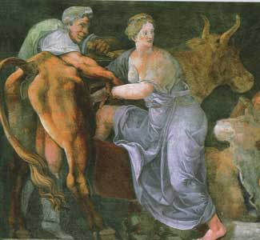

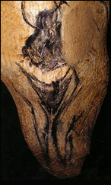

Fig. 3 Fig. 4

Credit: Centre National de Préhistoire Credit: Rosa Guirato

Inside Chauvet cave, an artist chose a stalactite, suggestive of a bull's phallus, to sketch a life-sized human vulva above two spindly bowed legs. Several thousand years later, another prehistoric image was added. A bison-headed figure, known as the Sorcerer, hovers over Venus, blending its leg with hers. Whether guarding or menacing, we cannot know. Its purpose may be mysterious, but the association with the vulva appears deliberate, for the bull is carefully positioned around the original composition. What is the relationship? Perhaps we may see through refraction.

The Greek myth of Pasiphaë and the Bull, in circulation around 1300 BC, represents a disavowal of Venus and the Sorcerer by the new patriarchal order. Overcome with desire for a bull, the goddess Pasiphaë, Queen of Crete, 'begins to haunt the fields/ A kind of Maenad, maddened...' (Ovid, 2014, ff. 311-2, p. 123). Baffled by human courtship, the bull ignores her. 'Why rearrange your hair five times a day?' mocks Ovid. 'Believe the glass that says you're not a cow' (ff. 306-7, p. 123). To win her beloved, Pasiphaë must transform into a Venus of Tolentino. In desperation, she commissions Daedalus, the court inventor, to build a wooden cow frame. Animism and human sexuality unite as 'the prize bull fill[s] her (hidden in a crate) [and] [t]he offspring proved just who had been her mate' (ff. 325-6, p. 124).

Pasiphaë's husband, King Minos, is unforgiving despite having been conceived in the similar manner when Zeus transformed into a white bull to abduct Europa. Shapeshifting in the guise of animals provides Zeus with easy access to human partners. Unlike Pasiphaë, he may engage in therianthropic sex because his method does not undermine the patriarchal order nor indulge in actual animism. An anthropomorphic god may turn himself into a bull to rape a woman, but a goddess may not turn herself into a cow to seduce a bull. In essence, Pasiphaë's authentic animism destabilizes the foundations of patriarchy and its privileging of the human phallus. Minos' domestic sphere represents his wider ownership in microcosm. Once Minos loses control over his wife and her exclusive reproduction of his heirs, the Cretan kingdom risks collapse. Ovid describes Pasiphaë's infidelity as a coup d’état: '[H]is overthrowing/ Was by a bull' (ff. 302-3, p. 123). It is emasculation by animist forces and thus represents a dangerous regression to the pre-phallic order. 'At least pick out a *man*', Ovid urges. 'Don't be obscene' (ff. 310, p. 123; original emphasis). For the patriarchy to wrest control from animism, Pasiphaë must be relegated to the grotesque, her offspring to the monstrous. Her transgression must be sublimated, locked underground in a labyrinth beneath the palace (Freud, 1991).

As ever, the subconscious has an appetite. The Minotaur stalks his prey through the maze, and he is hunted in turn. When the monster is slain, fresh fears reinvent him. If, as Jorge Luis Borges once said, 'it only takes two facing mirrors to construct a labyrinth' (1984, p. 33), Venus and the Sorcerer are one reflective surface and Pasiphaë is the other. We see ourselves refracted in both. Psychoanalysis navigates a complex, neurological topography, not unlike a reflective labyrinth. Our sustained engagement with the gendered subject of 2000 generations ago endures because the primordial resides within us. When pushed below the surface, it percolates up, flooding unexpected places. At Oostvaardersplassen in Holland, Holocene-weary tourists pay € 200 a day to wade through bogs rebranded as Pleistocene. Further afield, some thirty-six meters below Stockholm, the Solna Centrum Metro resembles a refurbished birth canal with escalators. Far-removed from the metropolis above, Solna's transitory space echoes the ochre-toned womb room of Gargas. Bison-headed therianthropes lope around Brooklyn parks like hipster Sorcerers of Chauvet in Rachel Frank's performances of 'Rewilding'. Artistic expression, Frank explains, 'is the collapsing of time where past and present can overlap' (Frank interview, 2016). Paleolithic Venus influences our decisions and preferences, guiding us unawares.

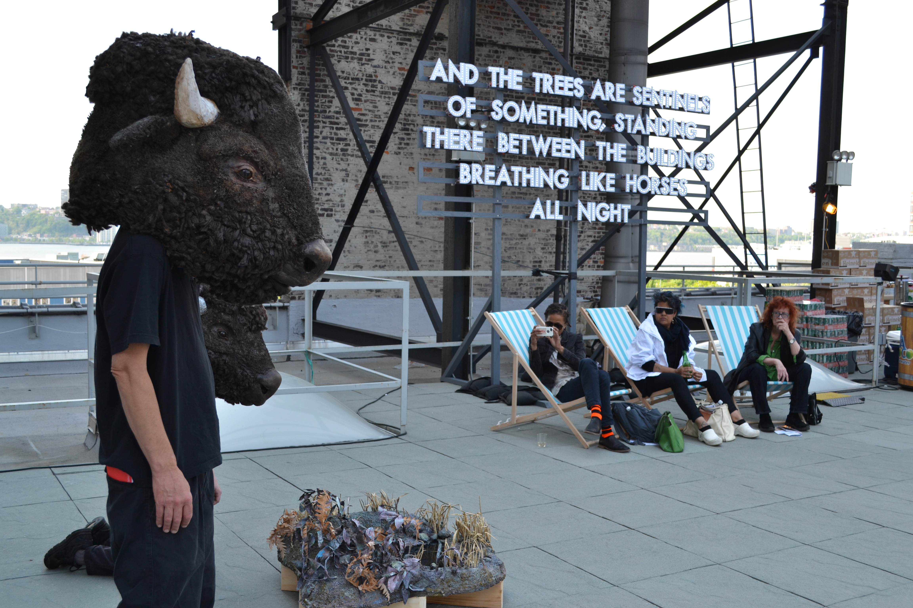

Fig. 5 Credit: Jessica Slaven

And Freud responds to her in spite of himself. Whether theorizing about the universality of mytho-archetypes or amassing trace evidence for his collection, he is forever shadowboxing with this woman. What would he have made of her latest appearance? In 2008, at Hohle Fels cave in Germany, another Venus emerged from the sediment. Sculpted from mammoth tusk about 40,000 years ago, she is the oldest image of a human being ever discovered (Figure 6: Jenson, 2009). Some researchers describe her as headless, distinguished by a prominent vulva and two 'ballooning' breasts floating above the shoulder-line (Conrad, 2009; Curry, 2012). For others, these balloons are not breasts but two heads bowed in an embrace and united by one body (Harrod, 2011). Although Freud never acknowledges their influence, these women slept inside his head. Power and wisdom flow between the two, perhaps as a transmission from mother to daughter (Ibid.). The Women of Hohle Fels at once defy Freud and confirm his premise. In eloquent expression of our collective unconscious, they join two minds, all minds, together as one.

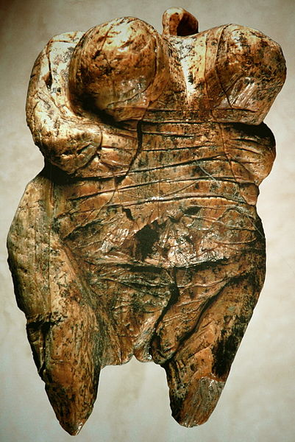

Fig. 6 Credit: Hilde Jensen

**Bibliography:**

Bahn, P.G. (1986). *No sex, please, we're Aurignacians*. Rock Art Research 3(2), 99-120.

Borges, J.L. (1984). Nightmares. In: *Seven Nights*. Translated from Spanish by Eliot Weinberger. New York: New Directions, 33.

Butler, J. (1990). *Gender Trouble: Feminism and the Subversion of Identity*. New York: Routledge, 139-40.

Burke, J. (2007). The Shrine of the Dream Collector. *Sigmund Freud's Collection. An Archeology of the Mind*. [online] Melbourne, Australia: Monash University Museum of Art. Available at: <https://sydney.edu.au/museums/publications/catalogues/freud-catalogue.pdf> [Accessed 4 April 2016], 7.

Conrad, N.J. (2009). The Female Figurine from the Basal Aurignacian of Hohle Fels Cave in Southwestern Germany. *Nature* 459, 248-52.

Curry, A. (2012). The Cave Art Debate. *Smithsonian*, [online] (Last updated March 2012). Available at: <http://www.smithsonianmag.com/history/the-cave-art-debate-100617099/ ?no-ist> [Accessed on March 2016].

Curtis, G. (2007). *The Cave Painters: Probing the Mysteries of the World's First Artists*. New York: Anchor.

Dixson, A.F. and Dixson, B.J. (2011). Venus Figurines of the European Paleolithic: Symbols of Fertility or Attractiveness? Journal of Anthropology, Vol. 2011, 1-11.

Foucher, P., San Juan-Foucher, C. and Rumeau, Y. (2007). *La Grotte de Gargas. Un Siècle de Découvertes*. Saint-Laurent-de-Neste, France: Édition Communautés de Communes du Canton de Saint-Laurent-de-Neste.

Freud, E.L., ed. (1975). *Letters of Sigmund Freud, 1887-1939*. Translated by Tania and James Stern. New York: Basic Books, 403.

Freud, S. (1889). Letter from Sigmund Freud to Wilhelm Fließ, 1st August 1889. In: J. Moussaieff Masson, ed. 1985. *The Complete Letters of Sigmund Freud to Wilhelm Fliess, 1887-1904*. Cambridge, MA: Harvard University Press, 363.

Freud, S. (1919). *Totem and Taboo: Resemblances Between the Psychic Lives of Savages and Neurotics*. Translated by A. A. Brill. New York: Moffat, Yard and Company, 150.

Freud, S. (1968a [1908]). On the Sexual Theories of Children. In: *The Standard Edition of the Complete Psychological Works of Sigmund Freud*, Vol. IX. Translated by James Strachey. London: Hogarth Press, 207.

Freud, S. (1968b [1923]). The Infantile Genital Organization. In: *The Standard Edition of the Complete Psychological Works of Sigmund Freud*, Vol. XIX. Translated by James Strachey. London: Hogarth Press, 141.

Freud, S. (1968c [1933]). Femininity. In: *The Standard Edition of the Complete Psychological Works of Sigmund Freud*, Vol. XXII. Translated by James Strachey. London: Hogarth Press, 113, 116.

Freud, S. (1977a [1905]). The Transformations of Puberty. In J. Strachey and A. Richards, eds. *On Sexuality: Three Essays on the Theory of Sexuality and Other Works*. London: Penguin, 143.

Freud, S. (1977b [1925]). Some Psychical Consequences of the Anatomical Distinction Between the Sexes. In J. Strachey and A. Richards, eds. *On Sexuality: Three Essays on the Theory of Sexuality and Other Works*. London: Penguin, 338, 342.

Freud, S. (1991 [1900]). *The Interpretation of Dreams*. Translated by J. Strachey. London: Penguin, 470-71.

Freud, S. (2001 [1939]). Moses and Monotheism. In: J. Strachey and A. Freud, eds. *The Standard Edition of the Complete Psychological Works of Sigmund Freud*, Vol. XXIII. Translated by James Strachey. London: Vintage, 83.

Giddens, A. (1991). *Modernity and Self-Identity: Self and Society in the Late Modern Age*. Stanford: Stanford University Press, 54.

Harrod, J. (2011). The Hohle Fels Female Figurine: Not Pornography but a Representation of the Upper Paleolithic Double Goddess. *The Journal of Archaeomythology* 2001, 1-14.

Hesiod. (2006 [~700 BC]). Theogony, Lines 176-187. In: G.M. Most, ed. *Hesiod*. Translated by G. M. Most from Ancient Greek. Cambridge, MA: Harvard University Press, 17-19

Kuspit, D. (1989). A Mighty Metaphor: The Analogy of Archaeology and Psychoanalysis. In: L. Gamwell and R. Wells, eds. *Sigmund Freud and Art: His Personal Collection of Antiquities*. New York: State University of New York, 133-51.

Mirazón Lahr, M. et al. (2016). Inter-group violence among early Holocene hunter-gatherers of West Turkana, Kenya. Nature 529, 394–98.

Ovid. (2014 [2 AD]). Ars Amatoria, Book 1. In: *Ovid's Erotic Poems: Amores and Ars Amatoria*. Translated from Latin by L. Kristak. Philadelphia: University of Pennsylvania Press, 123-24.

Panjekeff, S. (1972). My Recollections of Sigmund Freud. In: M. Gardiner, ed. *The Wolf-Man and Sigmund Freud*. London: Hogarth Press, 139.

Sauvet G. and Wlodarczyk, A. (2001). L'Art Pariétal, Mirroir des Sociétés Paleolithiques. *Zephyrus*, 53-5, 217-40.

Slocum, S.L. (1975). Woman the Gatherer: Male bias in Anthropology. In: R. Reiter, ed. *Toward an Anthropology of Women*. New York: Monthly Review Press, 36-50.

Soffer, O., Adovasio, J.M. and Hyland, D.C. (2000). The "Venus" Figurines: Textiles, Basketry, Gender and Status in the Upper Paleolithic. *Current Anthropology* 41(4), 511-37.

Vandiver, P.B., Soffer, O., Kilma, B. and Svoboda, J. (1998). The Origins of Ceramic Technology at Dolni Vecaronstonice, Czechoslovakia. *Science* 246(4933), 1002-08.

Wrangham, R. and Peterson, D. (1997). *Demonic Males: Apes and the Origins of Human Violence*. London: Bloomsbury.

Wright, R. P. (1996). Introduction: Gendered Ways of Knowing in Archaeology. In: R. P. Wright, ed. *Gender and Archaeology*. Philadelphia: University of Pennsylvania Press, 1-22.

**Images:**

Jensen, H. (2009). *Venus of Hohle Fels*. [image online] Available at: <http://www.geo.uni-tuebingen.de/fileadmin/website/arbeitsbereich/ufg/ urgeschichte_quartaeroekologie/medien/Venus/Venus.pdf> [Accessed 21 March 2016]. This 40,000-year-old artifact is being studied at University of Tübingen.

[*The Shaft of the Deadman*] n.d. [image online] Available at: https://en.wikipedia.org/wiki/Lascaux

Romano, G. (c. 1530). *Pasiphaë Enters in Daedalus' Wooden Cow* [image online] Available at: <http://www.scalarchives.com/scalapic/020996/c/0094641c.jpg> [Accessed 21 March 2016]. This fresco is located in the Hall of Amor and Psyche, Palazzo del Tel, Mantua, Italy.

[*Venus and the Sorcerer*] n.d. [image online] Available at: <http://www.bradshawfoundation.com/chauvet/venus_sorcerer.php>. This painting is located at Chauvet Cave, France

Slaven, J. (2014). *Rewilding.* [image online] Available at: http://rachelfrank.com/Rewilding-in-progress

~~[~~*~~Dolní Věstonice Venus~~*~~] n.d. [image online] Available at: <http://australianmuseum.net. au/dolni-vstonice-archaeological-site>. This 26,000 to 31,000-year-old artifact is located at the~~ [~~Naturhistorisches Museum~~](https://en.wikipedia.org/wiki/Naturhistorisches_Museum)~~,~~ [~~Vienna~~](https://en.wikipedia.org/wiki/Vienna)~~.~~

**Interview**

Frank, R. (2016). Contemporary artist interview, interviewed by Amanda Padoan via email on April 9, 2016.

**Endnotes**

1. "Woman" is the better term. As a term of art, "Venus" emphasizes her mythological associations and links to psychoanalysis, but the word has a shameful history. When archeologists first discovered these steatopygous figurines, the artifacts were christened Venus for their perceived similarities to Saartjie Baartman, a Koisan woman, exploited for her body type and exhibited at European circuses. Baartman's stage name was "Hottentot Venus".
2. Vandiver, Soffer, Kilma and Svoboda (1998) propose that Venus figurines were made to explode. Whether for ritual destruction or trade, their mass production is evident from the sheer number of fragments discarded at Dolní Věstonice.
3. The earliest, undisputed example of figurative art is the 40,000-year-old Venus of Hohle Fels, discovered in Germany in 2008. Other celebrated examples include:

   *Venus of Laussel*. Image available at: <https://en.wikipedia.org/wiki/ Venus_of_Laussel>. This 21,000-year-old artifact is located at the Musée d'Aquitaine in Bordeaux, France.

   *Venus of Lespugue.* Image available at: <https://en.wikipedia.org/wiki/ Venus_of_Lespugue>. This 24,000 to 26,000-year-old artifact is located at the Musée de l'Homme, Paris.

   *Venus of Moravany.* Image available at: <https://en.wikipedia.org/wiki/ Venus_of_Moravany>. This 23,000-year-old artifact is located at the Slovak National Museum's Bratislava Castle.

   *Venus of Kostenki.* Image available at: <http://donsmaps.com/ kostenkivenus.html>. This 24,000-year-old artifact is located at the Hermitage Museum, St. Petersburg.

   *Venus Rombo.* Image available at: <https://traveltoeat.com/venus-figurines-musee-darcheologie-nationale-chateau-de-saint-germain-en-laye-in-saint-germain-en-laye-france/>. This 22,000-year-old artifact is located at the Musée d'Archeologie Nationale et Domaine, St-Germain-en-Laye, France.

   *Venus of Willendorf.* Image available at: <https://en.wikipedia.org/wiki/ Venus_of_Willendorf>. This 24,000 to 26,000-year-old artifact is located at the [Naturhistorisches Museum](https://en.wikipedia.org/wiki/Naturhistorisches_Museum), [Vienna](https://en.wikipedia.org/wiki/Vienna).
4. A 2001 survey of cave art dating from the Upper Paleolithic reveals the relative frequency (and presumably, relative importance) of animal and human representations: horses and bison are represented in 27.6% of the art; deer, stags and hinds, 11.8%; ibex, 9.9%; mammoth, 8.6%; aurochs 5.7%; stylized humans, 3.4% (Sauvet and Wlodarczyk, 2001, p. 221).
5. *Venus of Tolentino*. Image available at: <http://donsmaps.com/ frasassivenus. html>. This 5,000 to 12,000-year-old artifact was last displayed at the Museo Archeologico Nazionale delle Marche di Ancona, Italy.
6. *Roc-aux-Sorciers vulvae*. Image available at: <http://donsmaps.com/ rocauxsorciers.html>. This palimpsest is located in Roc-aux-Sorciers Cave, France. See also: Pinçon, G., Iakovleva, L. and Fuentes, O., n.d. *Line drawing of Roc-aux-Sorciers underlayer*. Image available at: <http://donsmaps.com/rocauxsorciers.html>.
7. *Balsamarium*. Image available at: <https://sydney.edu.au/museums/ publications/catalogues/freud-catalogue.pdf>. This artifact (Etruscan, 3rd century BC) is located at the Freud Museum, London.
8. *Isis on Freud's desk.* Image available at: <https://sydney.edu.au/museums/ publications/catalogues/freud-catalogue.pdf>. This artifact (Egyptian, Late Period - 26th dynasty, 664-525 BC) is located at the Freud Museum, London.
9. *Artemis on Freud's desk.* Image available at: <https://sydney.edu.au/museums/ publications/catalogues/freud-catalogue.pdf>. This artifact (Greek Hellensic from Myrina, 2nd century BC) is located at the Freud Museum, London.
10. *Ishtar on Freud's desk.* Image available at: <https://sydney.edu.au/museums/ publications/catalogues/freud-catalogue.pdf>. This artifact (Syria, Middle Bronze Age, c. 2000-1750 BC) is located at the Freud Museum, London.
11. The quotation is attributed to Albert Einstein, who may have said this or something similar during a November 1946 radio interview. No transcript is known to exist.
12. Freud did not consider how intersex children or third gender children might dispute his developmental model. He describes boys and girls developing and differentiating out of a state of infantile bisexuality.
13. Wrangham and Peterson (1997) describe violence as an adaptation that predates the emergence of our subspecies. Presently the oldest, undisputed evidence of warfare is found at a 10,000-year-old site in Kenya called Nataruk (Mirazón Lahr et al., 2016).
14. *Scene of the Dead Man*. Image available at: <http://www.newworldencyclopedia org/entry/Lascaux>. This painting is located at the Lascaux Caves, France.
15. It is uncertain whether this etching found in Cueva de los Casares, Spain, represents human copulation or hierogamy.
16. Freud was fascinated by this stage of sexual development, 'which brings about so great an accession of libido in boys [and] is marked in girls by fresh waves of repression' (Freud 1977a, p. 143). Perhaps artistic expression undergoes a similar life cycle.